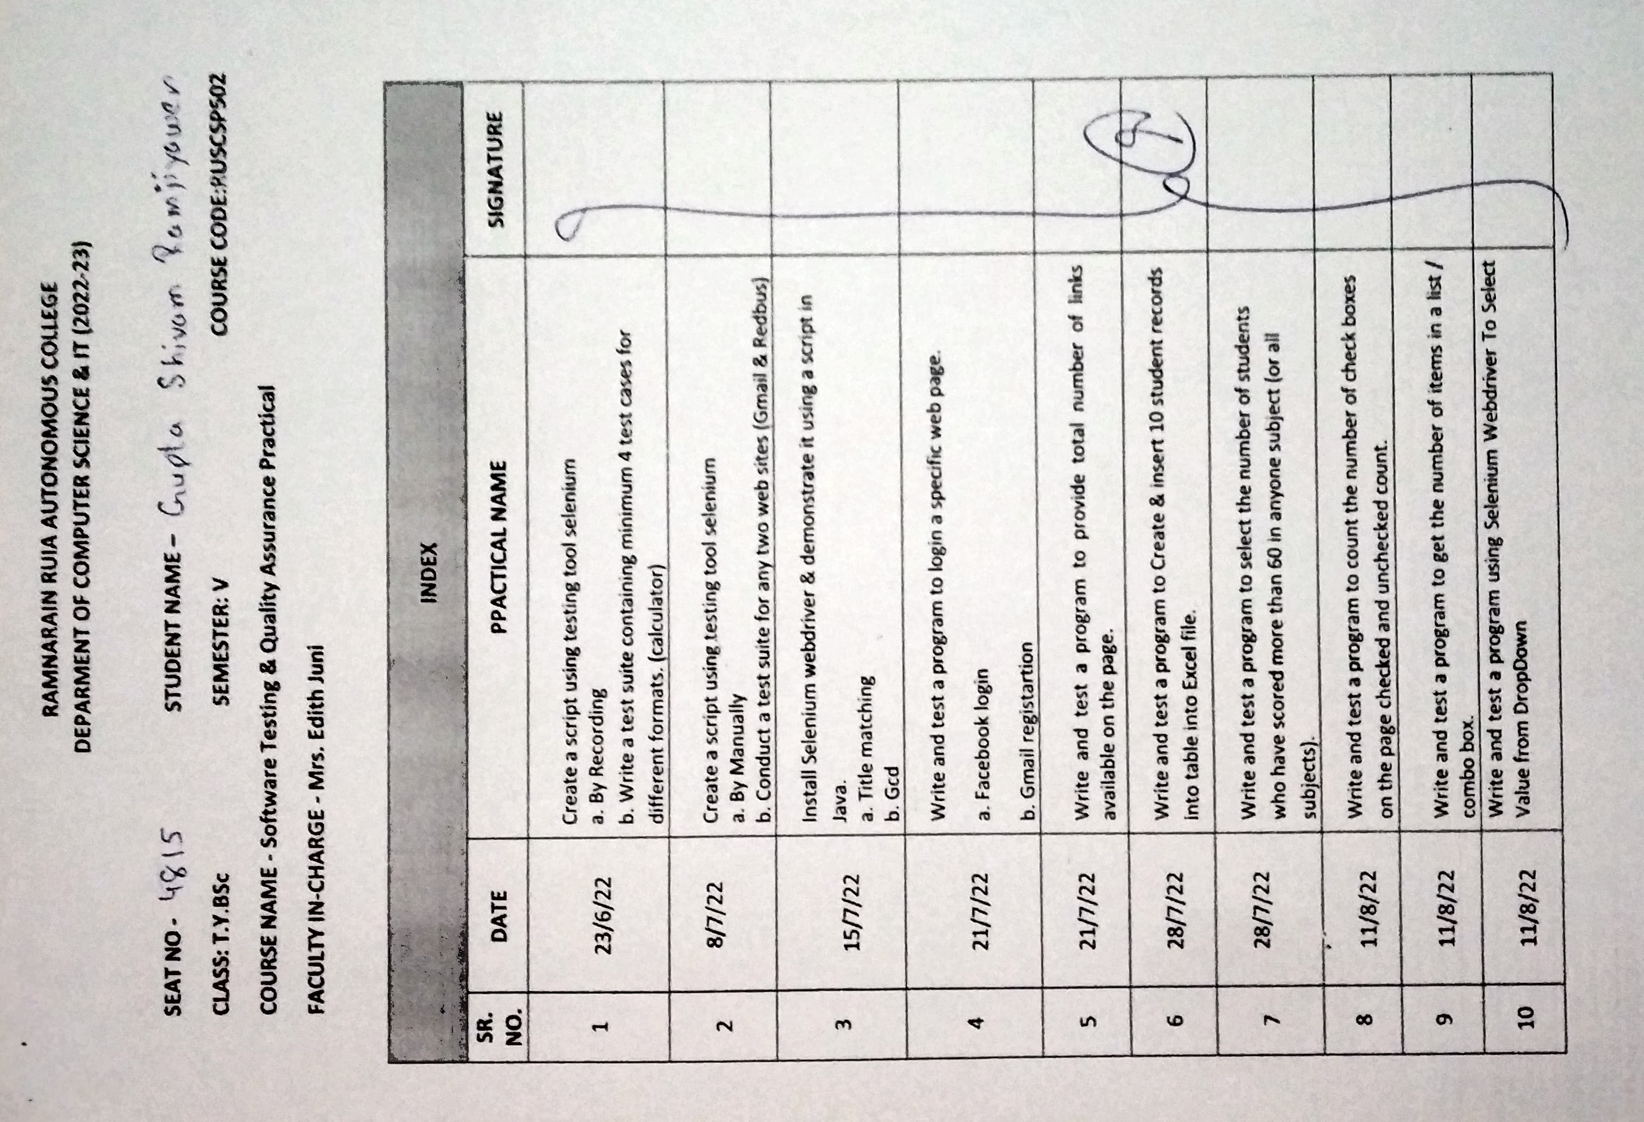



**Practical – 1**

**Aim:** **Create a script using testing tool selenium**

1. **By recording**
2. **Write a test suit containing minimum 4 test cases for different operations**
3. **Recording**

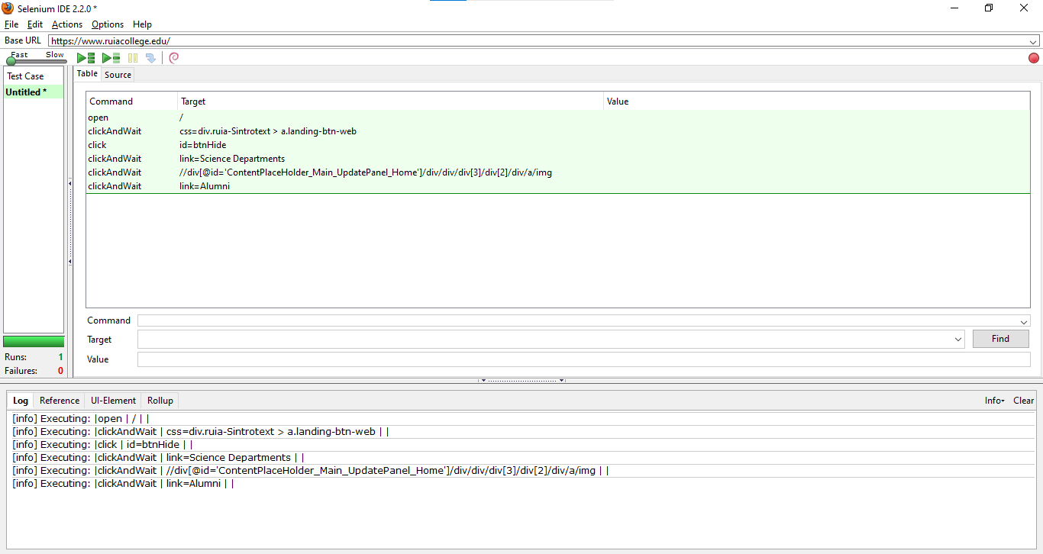

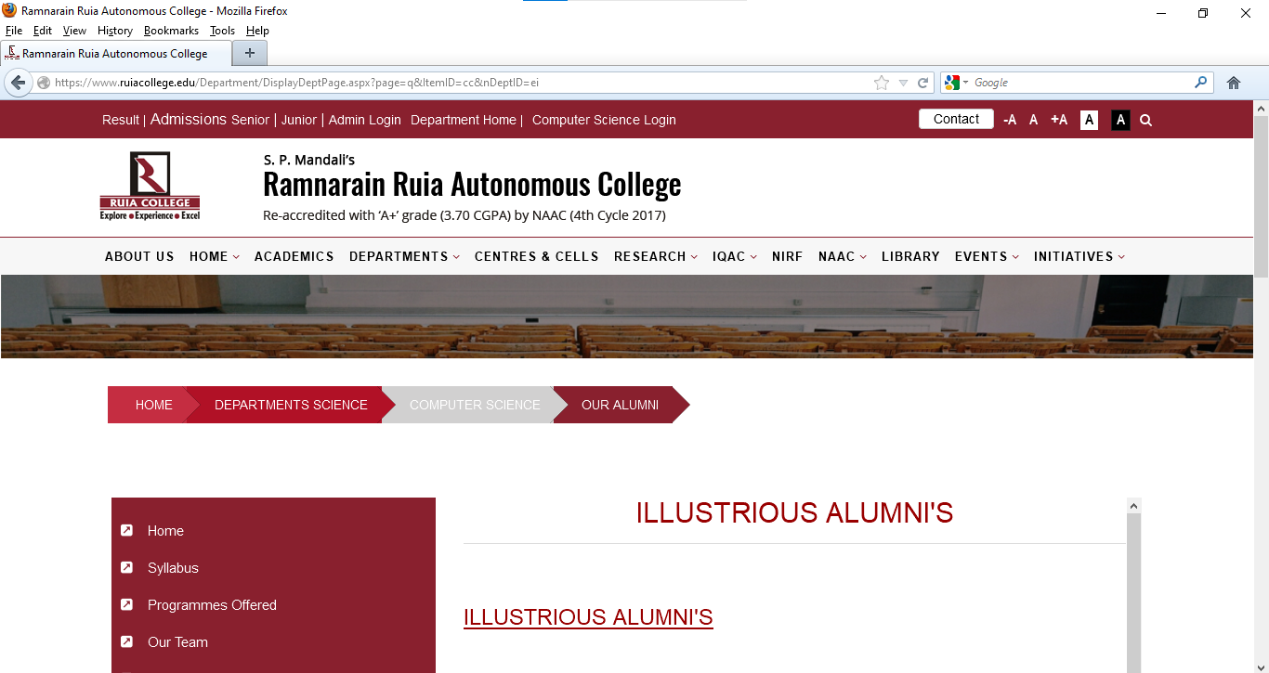

1. **Test cases**

**Code:**

<!DOCTYPE html>

<html lang="en">

<head>

    <meta charset="UTF-8">

    <meta http-equiv="X-UA-Compatible" content="IE=edge">

    <meta name="viewport" content="width=device-width, initial-scale=1.0">

    <title>Calculator</title>

</head>

<body>

    <center>

    <h1>Calculator</h1>

        <table >

            <tr >

                <td colspan="4"><input id="a" type="text" name="a" /></td>

            </tr>

            <tr >

                <td colspan="4"><input id="b" type="text" name="b" /></td>

            </tr>

            <tr>

                <td><button onclick="add()">Add</button></td>

                <td><button onclick="sub()">Sub</button></td>

                <td><button onclick="mul()">Mul</button></td>

                <td><button onclick="div()">Div</button></td>

            </tr>

            <tr>

                <td><label >Result: </label></td>

                <td><label id="res" colspan="4"></label></td>

            </tr>

        </table>

    </center>

    <script>

            // alert("add");

        function add(){

            const n1 = document.getElementById("a");

            const n2 = document.getElementById("b");

            const res = parseInt(n1.value) + parseInt(n2.value);

            document.getElementById("res").innerHTML = res;

        }

        function sub(){

            const n1 = document.getElementById("a");

            const n2 = document.getElementById("b");

            const res = parseInt(n1.value) - parseInt(n2.value);

            document.getElementById("res").innerHTML = res;

        }

        function mul(){

            const n1 = document.getElementById("a");

            const n2 = document.getElementById("b");

            const res = parseInt(n1.value) * parseInt(n2.value);

            document.getElementById("res").innerHTML = res;

        }

        function div(){

            const n1 = document.getElementById("a");

            const n2 = document.getElementById("b");

            const res = parseInt(n1.value) / parseInt(n2.value);

            document.getElementById("res").innerHTML = res;

        }

    </script>

</body>

</html>

**Output:**



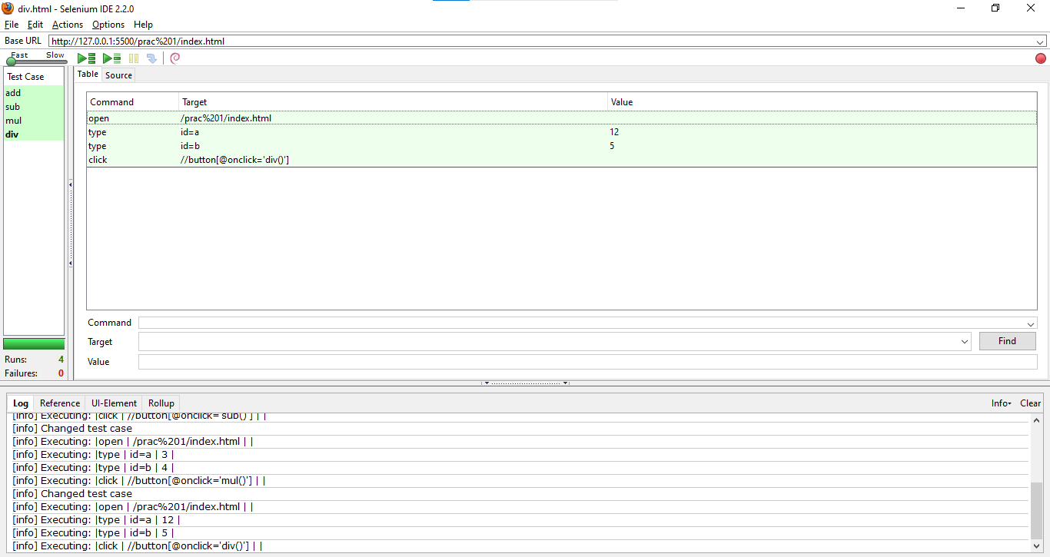

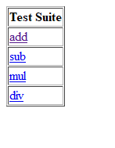 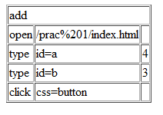 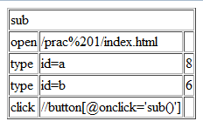

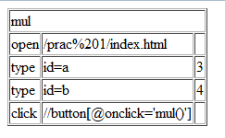 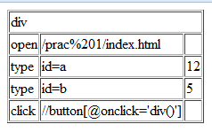

**Practical – 2**

**Aim: To Manually using commands and run prac 1**

**Note:** For this practical I’m using the latest(3.17.2) selenium ide as a chrome extension

**Testing page:**

<!**DOCTYPE** *html*>

<**html** *lang*="en">

<**head**>

    <**meta** *charset*="UTF-8">

    <**meta** *http-equiv*="X-UA-Compatible" *content*="IE=edge">

    <**meta** *name*="viewport" *content*="width=device-width, initial-scale=1.0">

    <**title**>Calculator</**title**>

</**head**>

<**body**>

    <**center**>

    <**h1**>Calculator</**h1**>

        <**table** >

            <**tr** >

                <**td** *colspan*="4"><**input** *id*="a" *type*="text" *name*="a" /></**td**>

            </**tr**>

            <**tr** >

                <**td** *colspan*="4"><**input** *id*="b" *type*="text" *name*="b" /></**td**>

            </**tr**>

            <**tr**>

                <**td**><**button** *name*="add" *onclick*="add()">Add</**button**></**td**>

                <**td**><**button** *name*="sub" *onclick*="sub()">Sub</**button**></**td**>

                <**td**><**button** *name*="mul" *onclick*="mul()">Mul</**button**></**td**>

                <**td**><**button** *name*="div" *onclick*="div()">Div</**button**></**td**>

            </**tr**>

            <**tr**>

                <**td**><**label** >Result: </**label**></**td**>

                <**td**><**label** *id*="res" *colspan*="4"></**label**></**td**>

            </**tr**>

        </**table**>

    </**center**>

    <**script**>

*// alert("add");*

*function* add(){

*const* n1 **=** document**.**getElementById("a");

*const* n2 **=** document**.**getElementById("b");

*const* res **=** parseInt(n1**.**value) **+** parseInt(n2**.**value);

            document**.**getElementById("res")**.**innerHTML **=** res;

        }

*function* sub(){

*const* n1 **=** document**.**getElementById("a");

*const* n2 **=** document**.**getElementById("b");

*const* res **=** parseInt(n1**.**value) **-** parseInt(n2**.**value);

            document**.**getElementById("res")**.**innerHTML **=** res;

        }

*function* mul(){

*const* n1 **=** document**.**getElementById("a");

*const* n2 **=** document**.**getElementById("b");

*const* res **=** parseInt(n1**.**value) **\*** parseInt(n2**.**value);

            document**.**getElementById("res")**.**innerHTML **=** res;

        }

*function* div(){

*const* n1 **=** document**.**getElementById("a");

*const* n2 **=** document**.**getElementById("b");

*const* res **=** parseInt(n1**.**value) **/** parseInt(n2**.**value);

            document**.**getElementById("res")**.**innerHTML **=** res;

        }

    </**script**>

</**body**>

</**html**>

**Writing test:**

In the selenium ide, create a new project(test suite).

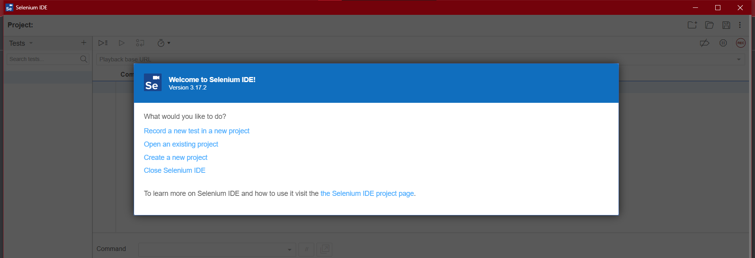

Type in your project name and click on OK.

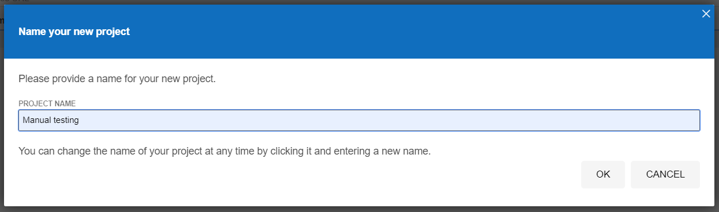

This is the UI that you’ll find.

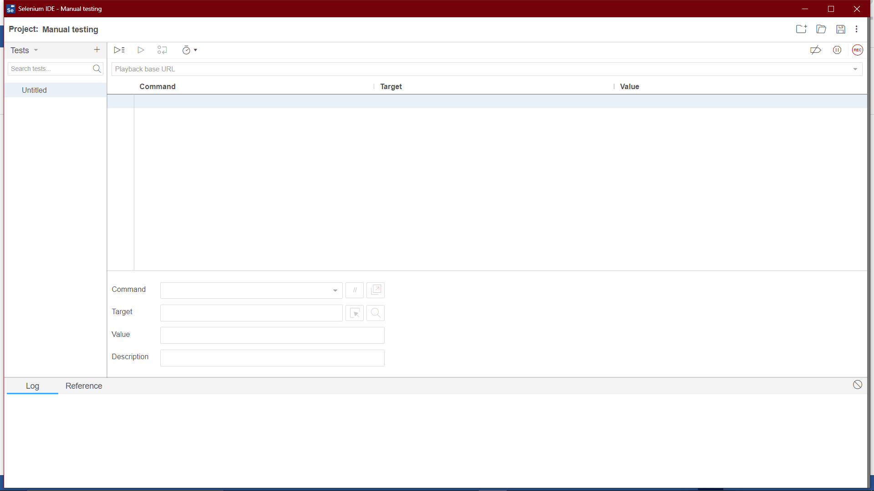

Type in the command that you want:

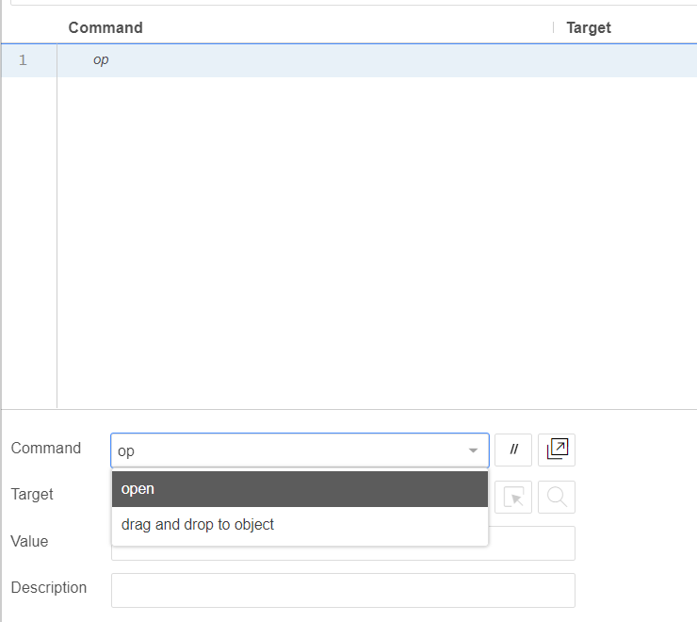

Type the target:

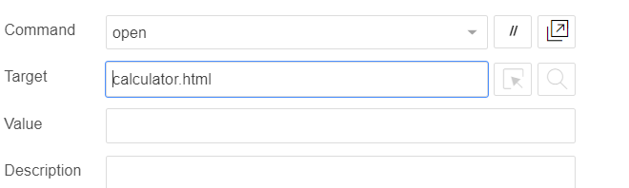

Press enter to save the command

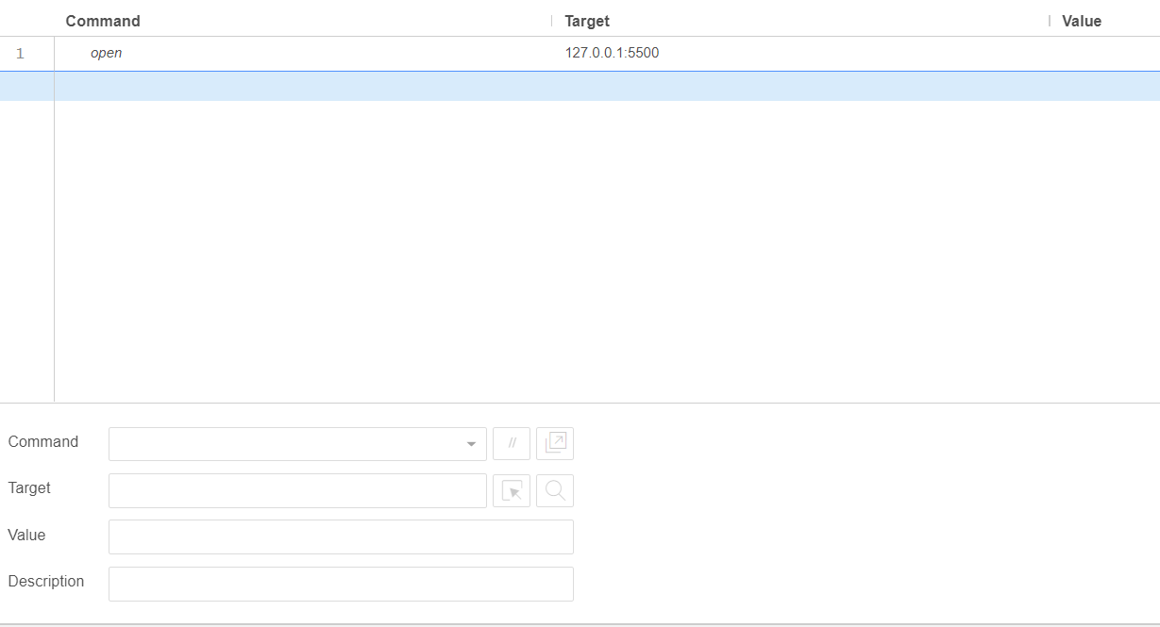

Similarly type in the commands, target and values for each step that you want to perform.

Here’s a test for checking addition .

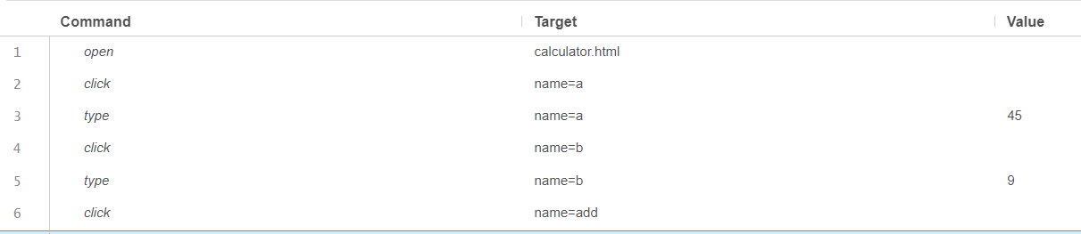

Rename Your test case:

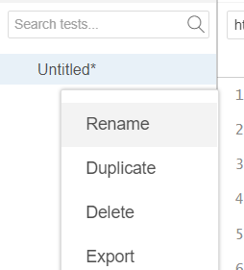

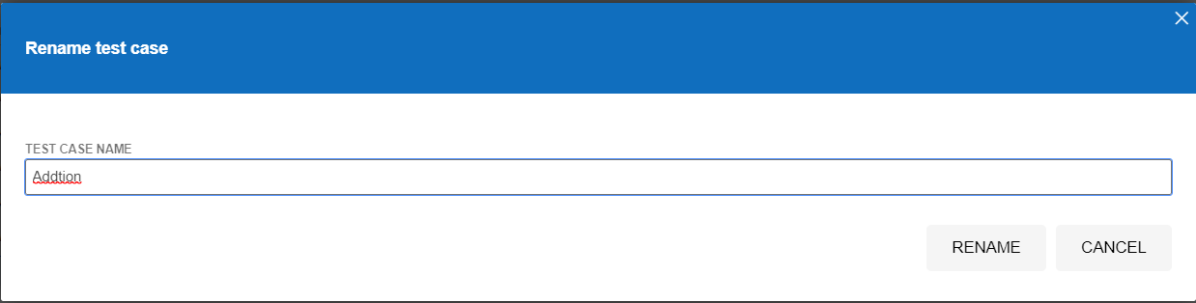

Then save the test case using “Ctrl+S” or clicking on “save” button.



Then, type the base url and run the current test case

(I’m using a local server so I have typed the localhost address and port number. You can simply type the file path).

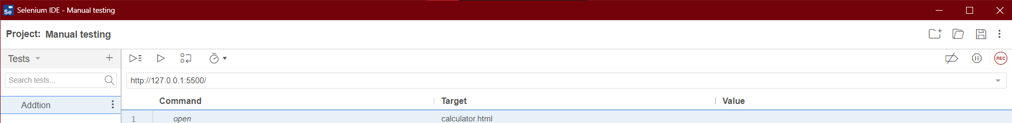

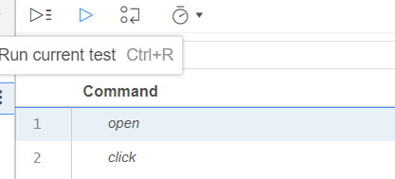

If you haven’t made any mistakes it will execute successfully.

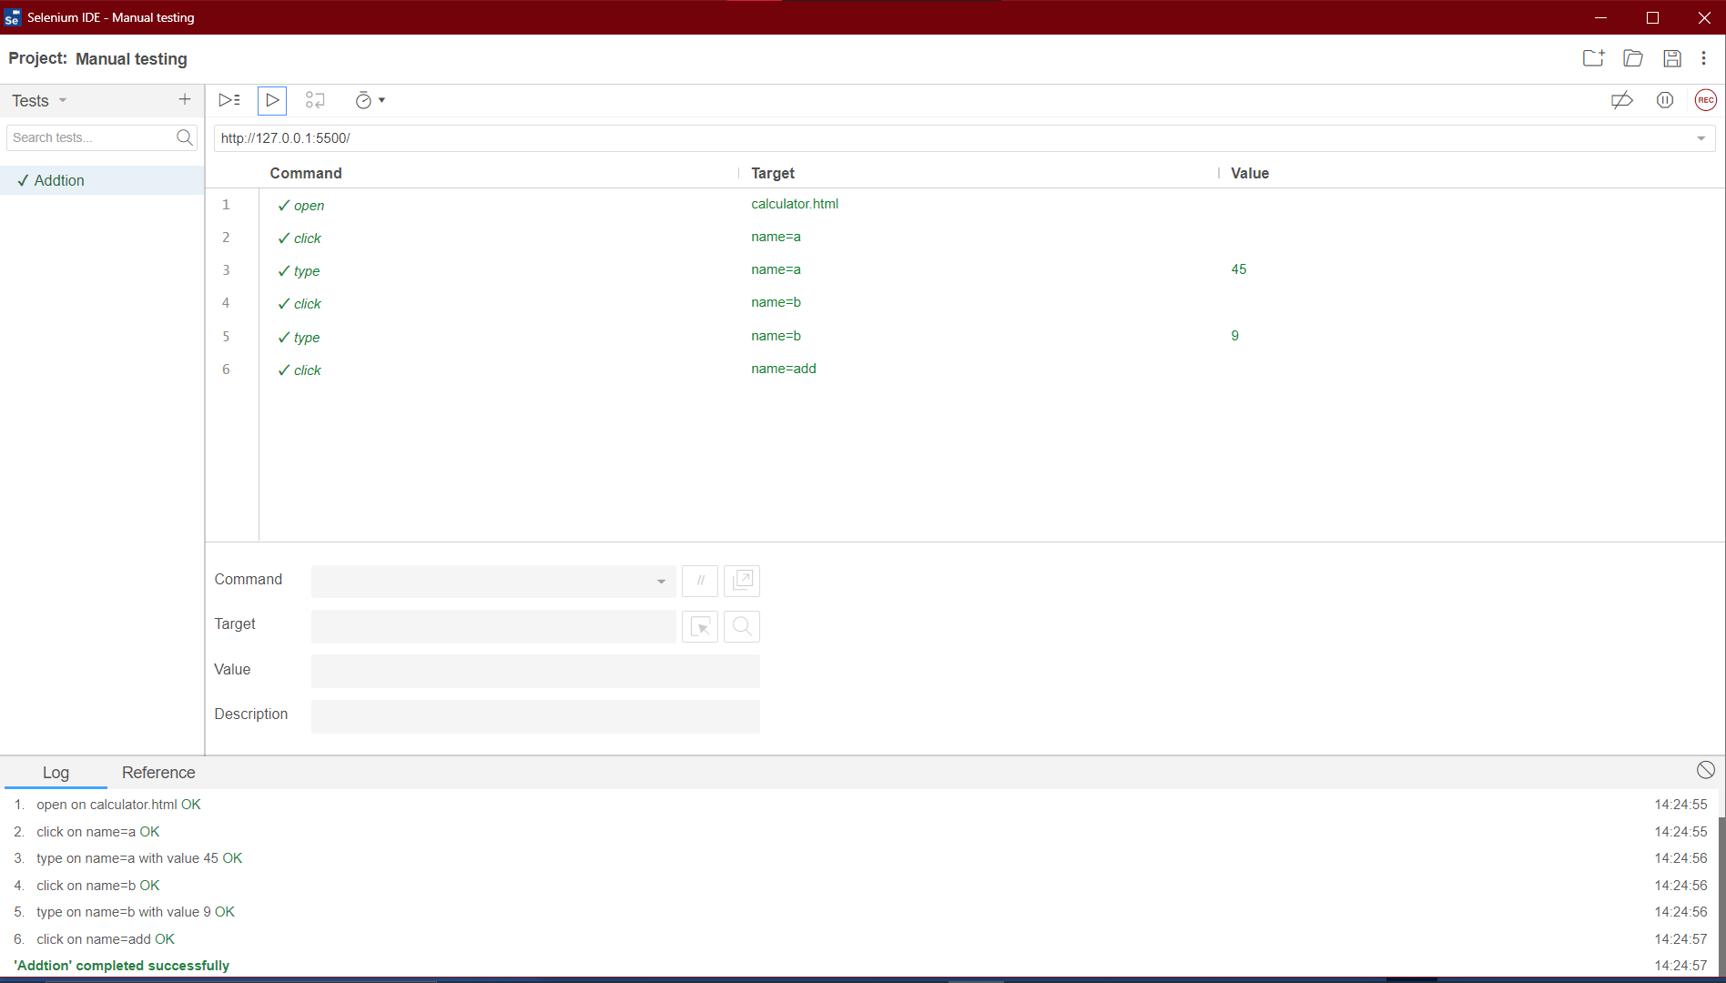

Similarly do the same for all operations:

**Output:**

1. **Addition:**

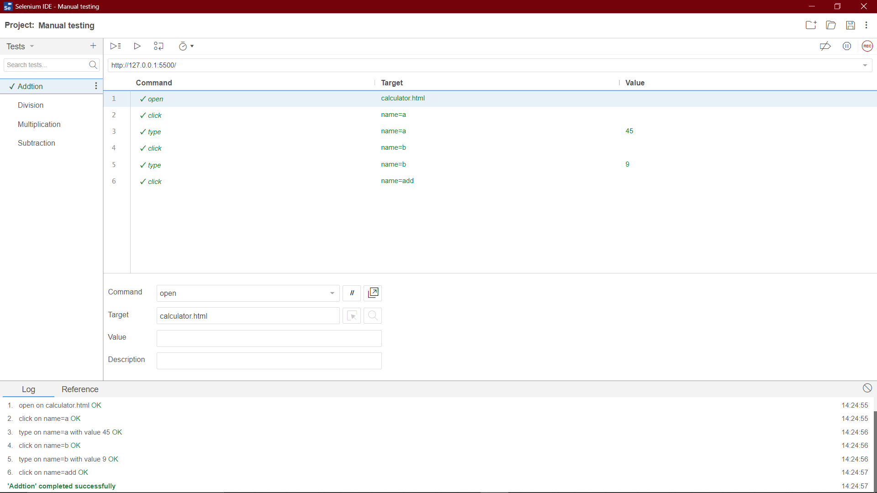

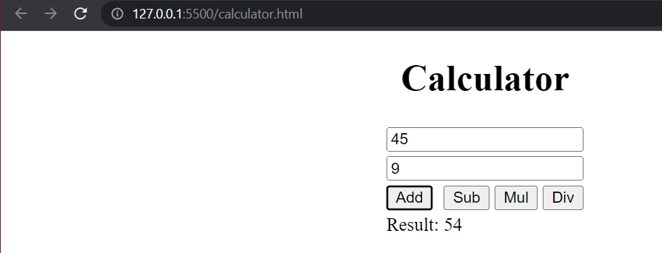

1. **Subtraction:**

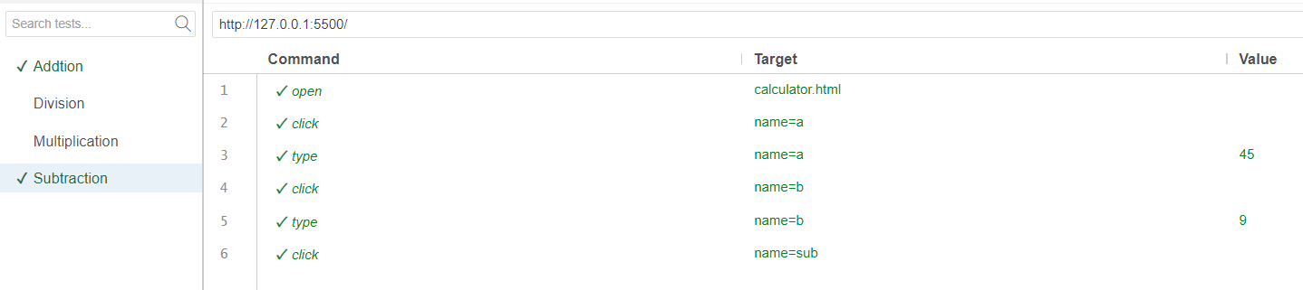

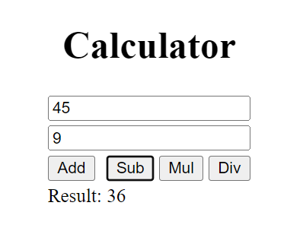

1. **Multiplication:**

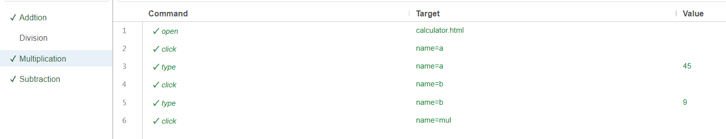

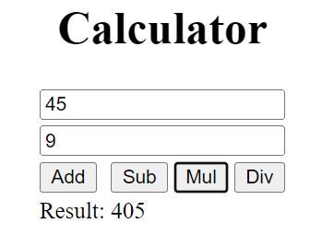

1. **Division:**

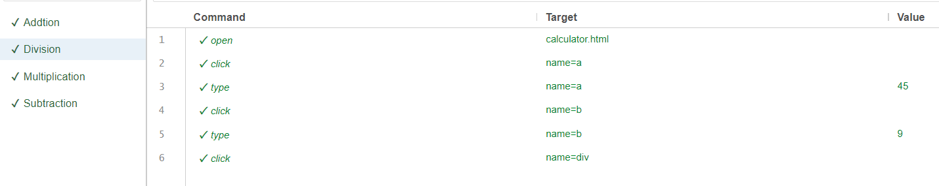

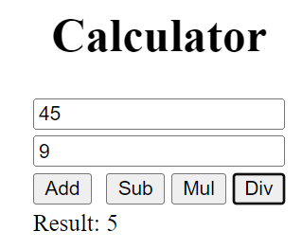

**Practical – 3**

**Aim: Browser testing using selenium java**

**Dependencies used:**

1. **Selenium 4.3.0**
2. **Geckodriver v0.31.0**

**Note:**

Add every jar file from the selenium folder and all the jars from lib folder

**GCD.html:**

<!DOCTYPE html>

<html lang="en">

<head>

<meta charset="UTF-8">

<meta http-equiv="X-UA-Compatible" content="IE=edge">

<meta name="viewport" content="width=device-width, initial-scale=1.0">

<title>GCD</title>

</head>

<body>

<script>

function gcd(){

console.log('gcd calculator')

// let x = parseInt(document.getElementById("n1").value);

// let y = parseInt(document.getElementById("n2").value);

let x = parseInt(document.form.n1.value);

let y = parseInt(document.form.n2.value);

// console.log(document.form.n1)

while (x!=y){

if(x>y){

x = x - y;

}

else{

y = y - x;

}

}

console.log(x);

document.form.res.value = x;

}

</script>

<h1>GCD calculator</h1>

<hr>

<center>

Enter two numbers:

<form name="form">

Number1: <input type="number" name="n1" id="n1" />

Number 2: <input type="number" name="n2" id="n2"/>

GCD: <input type="number" name="res" id="res" value="0">

</form>

<hr>

<br>

<button id="gcd" onClick="gcd()">GCD</button>

</center>

</body>

</html>

1. **Checking title**

**Code:**

**package** com.test.title;

**import** org.openqa.selenium.By;

**import** org.openqa.selenium.WebDriver;

**import** org.openqa.selenium.firefox.FirefoxDriver;

**public** **class** CheckTitle {

**static** String *driverPath* = "C:\\Users\\student\\Desktop\\TYBSC_4815\\STQA\\prac 3\\geckodriver.exe";

**public** **static** WebDriver *driver*;

**public** **static** **void** main(String[] args) {

System.*setProperty*("webdriver.gecko.driver", *driverPath*);

*driver* = **new** FirefoxDriver();

*driver*.get("file:///C:/Users/student/Desktop/TYBSC_4815/STQA/prac%203/gcd.html");

String actTitle = "GCD";

**if** (*driver*.getTitle().equals(actTitle)) {

System.***out***.println("Test Passed");

}**else** {

System.***out***.println("Test Failed");

}

*driver*.close();

System.*exit*(0);

}

}

**Output:**



1. **GCD**

**Code:**

package com.test.gcd;

import org.openqa.selenium.*;

import org.openqa.selenium.firefox.FirefoxDriver;

import org.openqa.selenium.remote.DesiredCapabilities;

public class CheckGcd {

static String driverPath = "C:\\Users\\student\\Desktop\\TYBSC_4815\\STQA\\prac 3\\geckodriver.exe";

public static WebDriver driver;

public static void main(String[] args) {

System.setProperty("webdriver.gecko.driver", driverPath);

driver = new FirefoxDriver();

driver.get("file:///C:/Users/student/Desktop/TYBSC_4815/STQA/prac%203/gcd.html");

driver.findElement(By.id("n1")).sendKeys("14");

driver.findElement(By.id("n2")).sendKeys("49");

driver.findElement(By.id("gcd")).click();

String result = driver.findElement(By.id("res")).getAttribute("value");

System.out.println("GCD is: "+result);

}

}

**Output:**

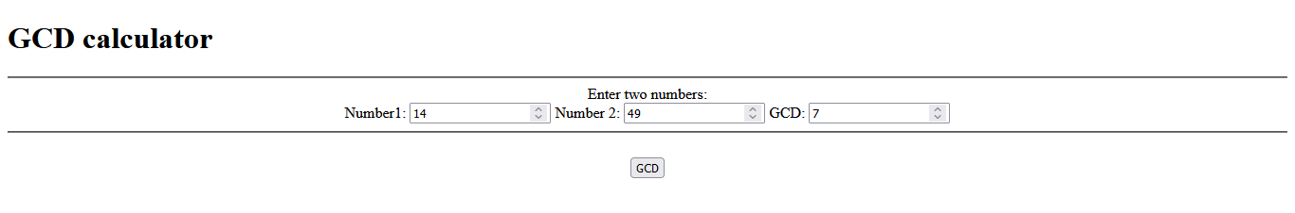



**Practical – 4**

**Aim: Perform automated Signup / Login**

1. **FaceBook login**

**Code:**

**package** com.automate;

**import** org.openqa.selenium.By;

**import** org.openqa.selenium.WebDriver;

**import** org.openqa.selenium.firefox.FirefoxDriver;

**public** **class** FacebookLogin {

**static** String *driverPath* = "C:\\Users\\student\\Desktop\\TYBSC_4815\\STQA\\prac 3\\geckodriver.exe";

**public** **static** WebDriver *driver*;

**public** **static** **void** main(String[] args) {

// **TODO** Auto-generated method stub

System.*setProperty*("webdriver.gecko.driver", *driverPath*);

*driver* = **new** FirefoxDriver();

*driver*.get("https://www.facebook.com/login/");

*driver*.findElement(By.*id*("email")).sendKeys("laksh@gmail.com");

*driver*.findElement(By.*id*("pass")).sendKeys("7035429871");

*driver*.findElement(By.*id*("loginbutton")).click();

}

}

**Output:**

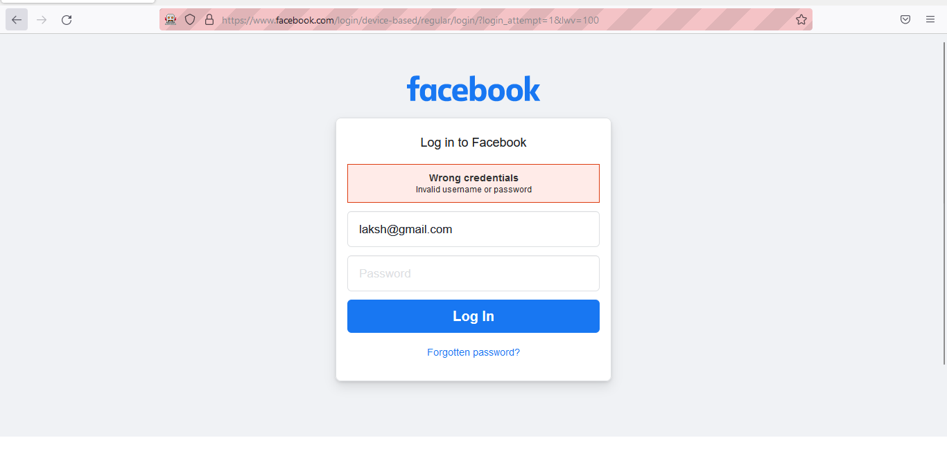

1. **Gmail signup**

Code:

**package** com.automate;

**import** org.openqa.selenium.By;

**import** org.openqa.selenium.firefox.FirefoxDriver;

**import** org.openqa.selenium.WebDriver;

**public** **class** GmailSignup {

**static** String *driverPath* = "C:\\Users\\student\\Desktop\\TYBSC_4815\\STQA\\prac 3\\geckodriver.exe";

**public** **static** WebDriver *driver*;

**public** **static** **void** main(String[] args) {

// **TODO** Auto-generated method stub

System.*setProperty*("webdriver.gecko.driver", *driverPath*);

*driver* = **new** FirefoxDriver();

*driver*.get("https://accounts.google.com/signup/v2/webcreateaccount?service=mail&continue=https%3A%2F%2Fmail.google.com%2Fmail%2F&flowName=GlifWebSignIn&flowEntry=SignUp");

*driver*.findElement(By.*id*("firstName")).sendKeys("Gucci");

*driver*.findElement(By.*id*("lastName")).sendKeys("Foyerkar");

*driver*.findElement(By.*id*("username")).sendKeys("guccifoyer101");

*driver*.findElement(By.*name*("Passwd")).sendKeys("gucci.Foyer.1@1");

*driver*.findElement(By.*name*("ConfirmPasswd")).sendKeys("gucci.Foyer.1@1");

*driver*.findElement(By.*xpath*("/html/body/div[1]/div[1]/div[2]/div[1]/div[2]/div/div/div[2]/div/div[2]/div/div[1]/div/div/button")).click();

}

}

Output:

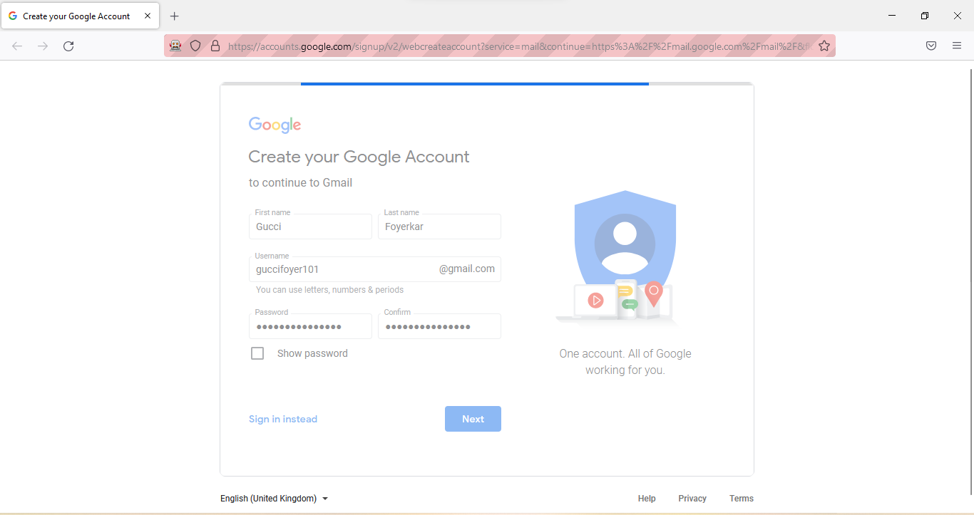

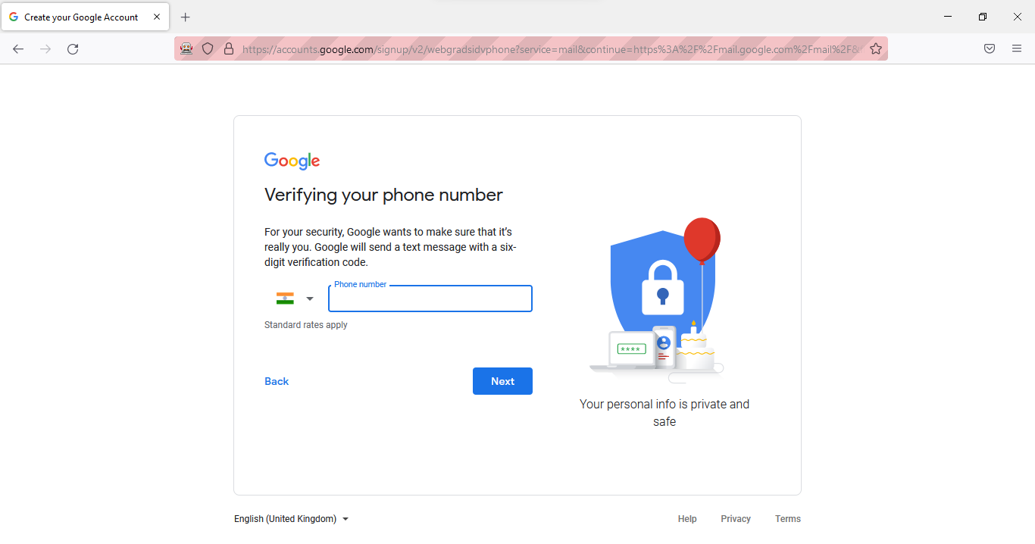

**Practical – 5**

**Aim:** **Write and test a program to provide total number of links available on the page**

**Code:**

**package** com.count;

**import** org.openqa.selenium.By;

**import** org.openqa.selenium.firefox.FirefoxDriver;

**import** org.openqa.selenium.WebDriver;

**import** org.openqa.selenium.WebElement;

**import** java.util.List;

**public** **class** LinkCount {

**static** String *driverPath* = "C:\\Users\\student\\Desktop\\TYBSC_4815\\STQA\\prac 3\\geckodriver.exe";

**public** **static** WebDriver *driver*;

**public** **static** **void** main(String[] args) {

System.*setProperty*("webdriver.gecko.driver", *driverPath*);

*driver* = **new** FirefoxDriver();

*driver*.get("https://www.wikipedia.org/");

List<WebElement> links = *driver*.findElements(By.*tagName*("a"));

System.***out***.println("Link count: "+links.size());

System.***out***.println("No.\tName");

**for** (**int** i = 0; i < links.size(); i++) {

System.***out***.println(""+i+"\t"+links.get(i).getText());

}

*driver*.close();

}

}

**Output:**

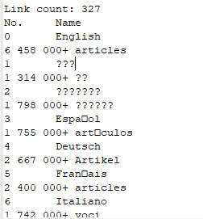

**Practical – 6**

**Aim: Write a program to create and insert 10 student records into table into excel file.**

**Note: Add jxl jar file in the project classpath**

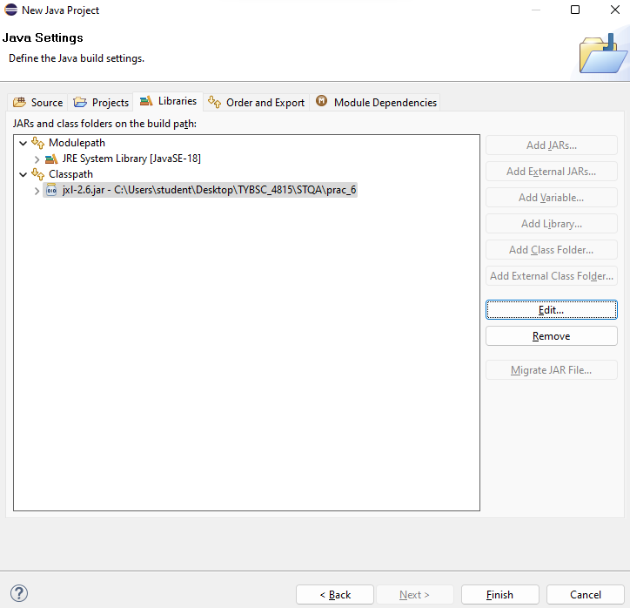

**Code:**

package com.code;

import java.io.File;

import java.io.IOException;

import java.util.Locale;

import jxl.CellView;

import jxl.Workbook;

import jxl.WorkbookSettings;

import jxl.format.UnderlineStyle;

import jxl.write.Label;

import jxl.write.Number;

import jxl.write.WritableCellFormat;

import jxl.write.WritableFont;

import jxl.write.WritableSheet;

import jxl.write.WritableWorkbook;

import jxl.write.WriteException;

import jxl.write.biff.RowsExceededException;

public class Creation {

private WritableCellFormat timesBoldUnderline;

private WritableCellFormat times;

private String inputFile;

public void setOutputFile(String inputFile) {

this.inputFile = inputFile;

}

public void write() throws IOException, WriteException{

File file = new File(inputFile);

WorkbookSettings settings = new WorkbookSettings();

settings.setLocale(new Locale("en", "EN"));

WritableWorkbook workbook = Workbook.createWorkbook(file,settings);

workbook.createSheet("Report", 0);

WritableSheet sheet = workbook.getSheet(0);

createLabel(sheet);

createContent(sheet);

workbook.write();

workbook.close();

}

private void createContent(WritableSheet sheet) throws WriteException{

// TODO Auto-generated method stub

for (int i = 1; i < 10; i++) {

// First column

addLabel(sheet, 0, i, "Student " + i);

// Second column

addNumber(sheet, 1, i, ((i*i)+10));

addNumber(sheet, 2, i, ((i*i)+4));

addNumber(sheet, 3, i, ((i*i)+3));

}

}

private void addNumber(WritableSheet sheet, int column, int row, int integer) throws RowsExceededException, WriteException {

// TODO Auto-generated method stub

Number number;

number = new Number(column, row, integer, times);

sheet.addCell(number);

}

private void addLabel(WritableSheet sheet, int column, int row, String s) throws RowsExceededException, WriteException {

// TODO Auto-generated method stub

Label label;

label = new Label(column, row, s, times);

sheet.addCell(label);

}

private void addCaption(WritableSheet sheet, int column, int row, String s) throws RowsExceededException,WriteException {

// TODO Auto-generated method stub

Label label;

label = new Label(column, row, s, timesBoldUnderline);

sheet.addCell(label);

}

private void createLabel(WritableSheet sheet) throws WriteException {

// TODO Auto-generated method stub

WritableFont font = new WritableFont(WritableFont.TIMES, 10);

times = new WritableCellFormat(font);

times.setWrap(true);

WritableFont headFont = new WritableFont(WritableFont.TIMES, 10, WritableFont.BOLD, false,UnderlineStyle.SINGLE);

timesBoldUnderline = new WritableCellFormat(headFont);

timesBoldUnderline.setWrap(true);

addCaption(sheet, 0, 0, "Student Name");

addCaption(sheet, 1, 0, "Subject 1");

addCaption(sheet, 2, 0, "subject 2");

addCaption(sheet, 3, 0, "subject 3");

}

public static void main(String[] args) throws WriteException, IOException {

Creation test = new Creation();

// test.setOutputFile("C:\\Users\\student\\Desktop\\a.xls");

test.setOutputFile("C:\\Users\\student\\Desktop\\TYBSC_4815\\STQA\\prac_6\\output.xls");

test.write();

System.out.println("Please check the result file under C:\\Users\\student\\Desktop\\TYBSC_4815\\STQA\\prac_6\\output.xls ");

}

}

**Output:**

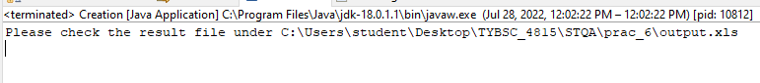

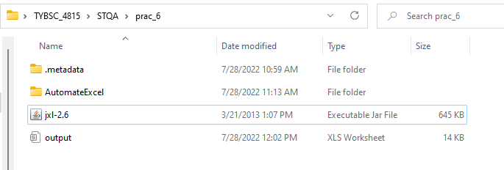

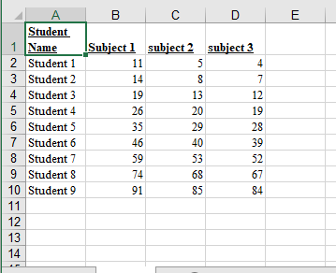

**Practical – 7**

**Aim:** Write and test a program to select the number of students who have scored more than 60 in anyone subject (or all subjects).

**Code:**

**package** summary;

**import** java.io.File;

**import** java.io.IOException;

**import** jxl.Cell;

**import** jxl.Sheet;

**import** jxl.Workbook;

**import** jxl.read.biff.BiffException;

**public** **class** Summarise {

**private** String inputFile;

**public** **int** count = 0;

**public** **void** setInputFile(String inputFile) {

**this**.inputFile = inputFile;

}

**public** **void** read() **throws** IOException, BiffException {

File file = **new** File(inputFile);

Workbook workbook = Workbook.*getWorkbook*(file);

Sheet sheet = workbook.getSheet(0);

**for** (**int** i = 1; i < sheet.getRows(); i++) {

**for** (**int** j = 1; j < sheet.getColumns(); j++) {

Cell cell = sheet.getCell(j,i);

**if** (Integer.*parseInt*(cell.getContents()) >= 60) {

count++;

break;

}

}

}

}

**public** **static** **void** main(String[] args) **throws** IOException, BiffException {

// **TODO** Auto-generated method stub

Summarise obj = **new** Summarise();

obj.setInputFile("C:\\Users\\student\\Desktop\\TYBSC_4815\\STQA\\prac_6\\output.xls");

obj.read();

System.***out***.println("Row count is: "+obj.count);

}

}

**Output:**



**Practical – 8**

**Aim:** Write and test a program to count the number of check boxes on the page checked and unchecked count

**Note:** We’ll be using chrome for this practical and thus, we need chromedriver.

**Code:**

**package** com.automate;

**import** org.openqa.selenium.By;

**import** org.openqa.selenium.WebDriver;

**import** org.openqa.selenium.chrome.ChromeDriver;

**import** org.openqa.selenium.WebElement;

**public** **class** CheckCount {

**public** **static** **void** main(String[] args) {

// **TODO** Auto-generated method stub

System.*setProperty*("webdriver.chrome.driver", "C:\\Users\\student\\Desktop\\TYBSC_4815\\STQA\\prac_8\\chromedriver.exe");

WebDriver driver = **new** ChromeDriver();

String baseUrl = "http://demo.guru99.com/test/login.html";

driver.get(baseUrl);

WebElement email = driver.findElement(By.*id*("email"));

WebElement passwd = driver.findElement(By.*id*("passwd"));

WebElement login = driver.findElement(By.*name*("SubmitLogin"));

email.sendKeys("abcd@gmail.com");

passwd.sendKeys("AttackOnTitan");

System.***out***.println("Text field set");

email.clear();

passwd.clear();

System.***out***.println("Text field cleared");

email.sendKeys("abcd@gmail.com");

passwd.sendKeys("AttackOnTitan");

login.click();

System.***out***.println("Login Done with click");

driver.get("http://demo.guru99.com/test/radio.html");

WebElement radio1 = driver.findElement(By.*id*("vfb-7-1"));

WebElement radio2 = driver.findElement(By.*id*("vfb-7-2"));

WebElement check1 = driver.findElement(By.*id*("vfb-6-0"));

radio1.click();

System.***out***.println("Radio button option 1");

radio2.click();

System.***out***.println("Radio button option 2");

check1.click();

**if** (check1.isSelected()) {

System.***out***.println("Checkbox is toggled on");

}**else** {

System.***out***.println("Checkbox is toggled off");

}

driver.get("http://demo.guru99.com/test/facebook.html");

WebElement chkFBPersist = driver.findElement(By.*id*("persist_box"));

**for** (**int** i=0; i<2; i++) {

chkFBPersist.click ();

System.***out***.println("Facebook Persists Checkbox Status is - "+chkFBPersist.isSelected());

}

driver.close();

}

}

**Output:**

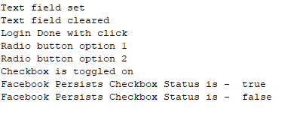

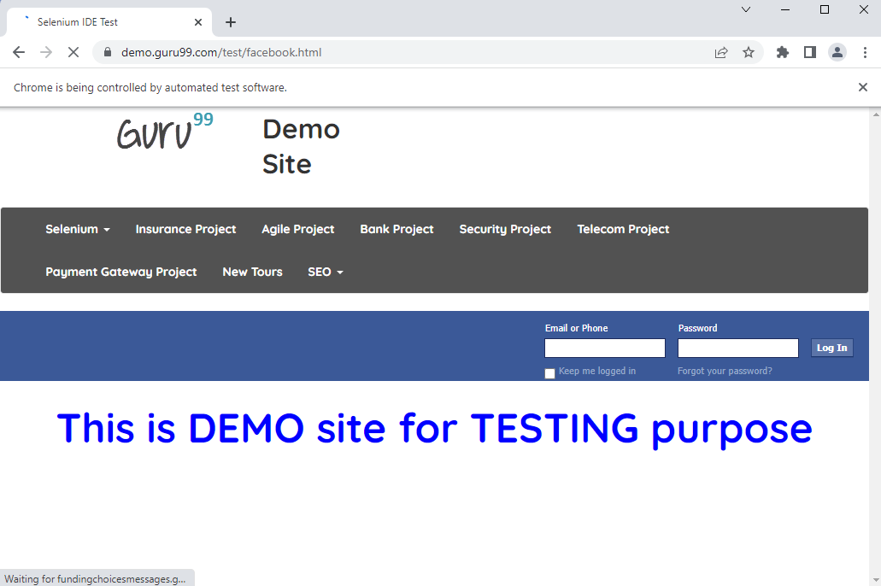



**Practical – 9**

**Aim:** Write and test a program to get the number of items in a list / combo box.

**Code:**

**package** com.automate;

**import** java.util.List;

**import** org.openqa.selenium.By;

**import** org.openqa.selenium.WebDriver;

**import** org.openqa.selenium.chrome.ChromeDriver;

**import** org.openqa.selenium.WebElement;

**import** org.openqa.selenium.support.ui.Select;

**public** **class** optionCount {

**public** **static** **void** main(String[] args) {

System.*setProperty*("webdriver.chrome.driver", "C:\\Users\\student\\Desktop\\TYBSC_4815\\STQA\\prac_9\\chromedriver.exe");

WebDriver driver = **new** ChromeDriver();

driver.get("C:\\Users\\student\\Desktop\\TYBSC_4815\\STQA\\prac_9\\combo.html");

Select selectDropdown = **new** Select(driver.findElement(By.*id*("Mobiles")));

List<WebElement> listOptions = selectDropdown.getOptions();

System.***out***.println("Total Number of item count in dropdown list = " + listOptions.size());

driver.close();

}

}

**Output:**



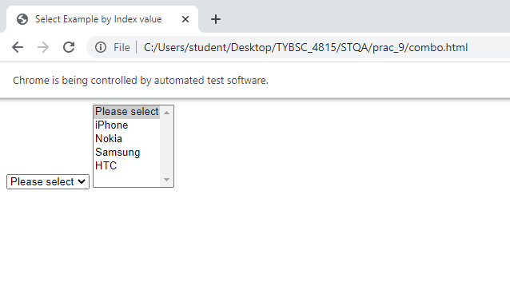

**Practical – 10**

**Aim:** Write and test a program using Selenium Webdriver To Select Value from DropDown.

**Code:**

**package** com.automate;

//import java.util.List;

**import** org.openqa.selenium.By;

**import** org.openqa.selenium.WebDriver;

//import org.openqa.selenium.WebElement;

**import** org.openqa.selenium.chrome.ChromeDriver;

**import** org.openqa.selenium.support.ui.Select;

**public** **class** OptionValue {

**public** **static** **void** main(String[] args) {

// **TODO** Auto-generated method stub

System.*setProperty*("webdriver.chrome.driver", "C:\\Users\\student\\Desktop\\TYBSC_4815\\STQA\\prac_9\\chromedriver.exe");

WebDriver driver = **new** ChromeDriver();

driver.get("C:\\Users\\student\\Desktop\\TYBSC_4815\\STQA\\prac_9\\combo.html");

Select selectDropdown = **new** Select(driver.findElement(By.*id*("Mobiless")));

// List<WebElement> listOptions = selectDropdown.getOptions();

selectDropdown.selectByVisibleText("Samsung");

selectDropdown.selectByIndex(3);

}

}

**Output:**

